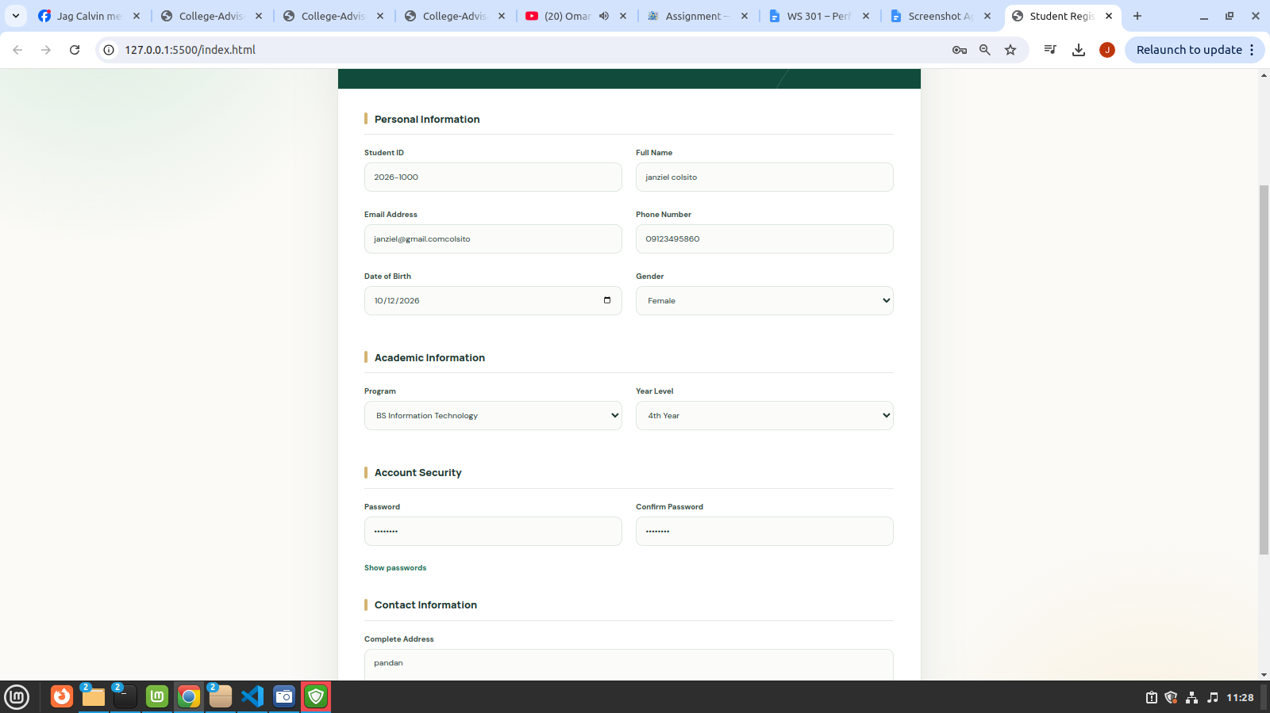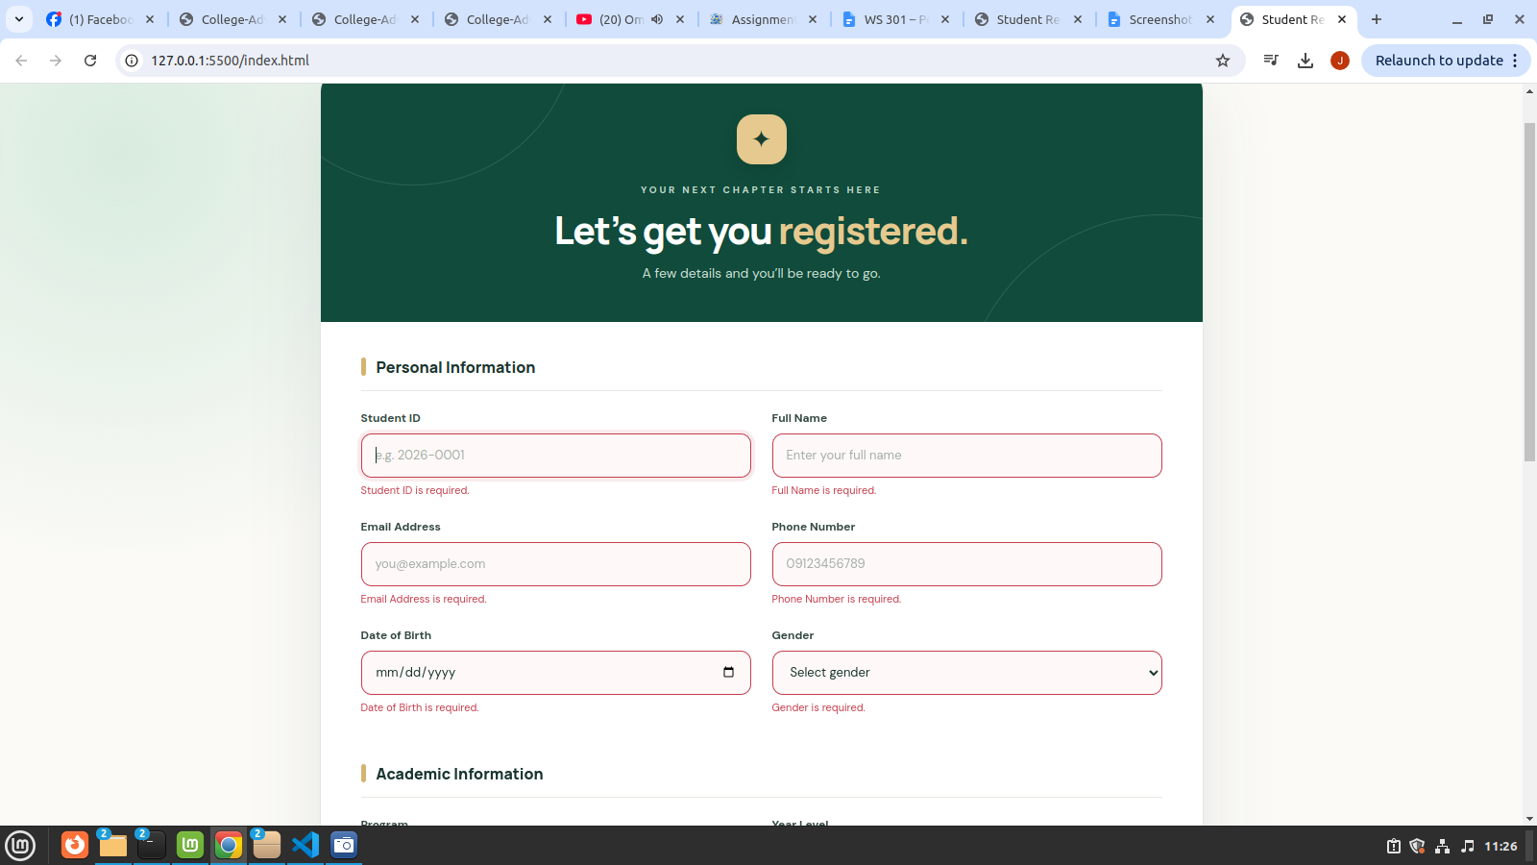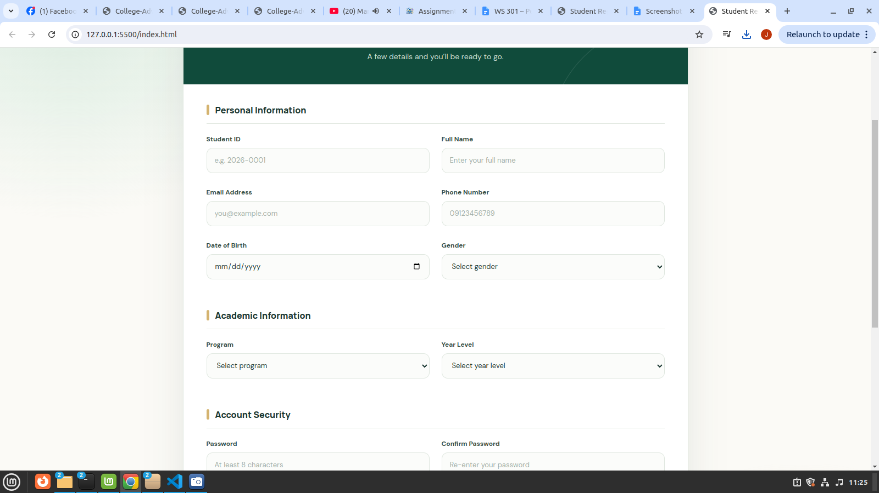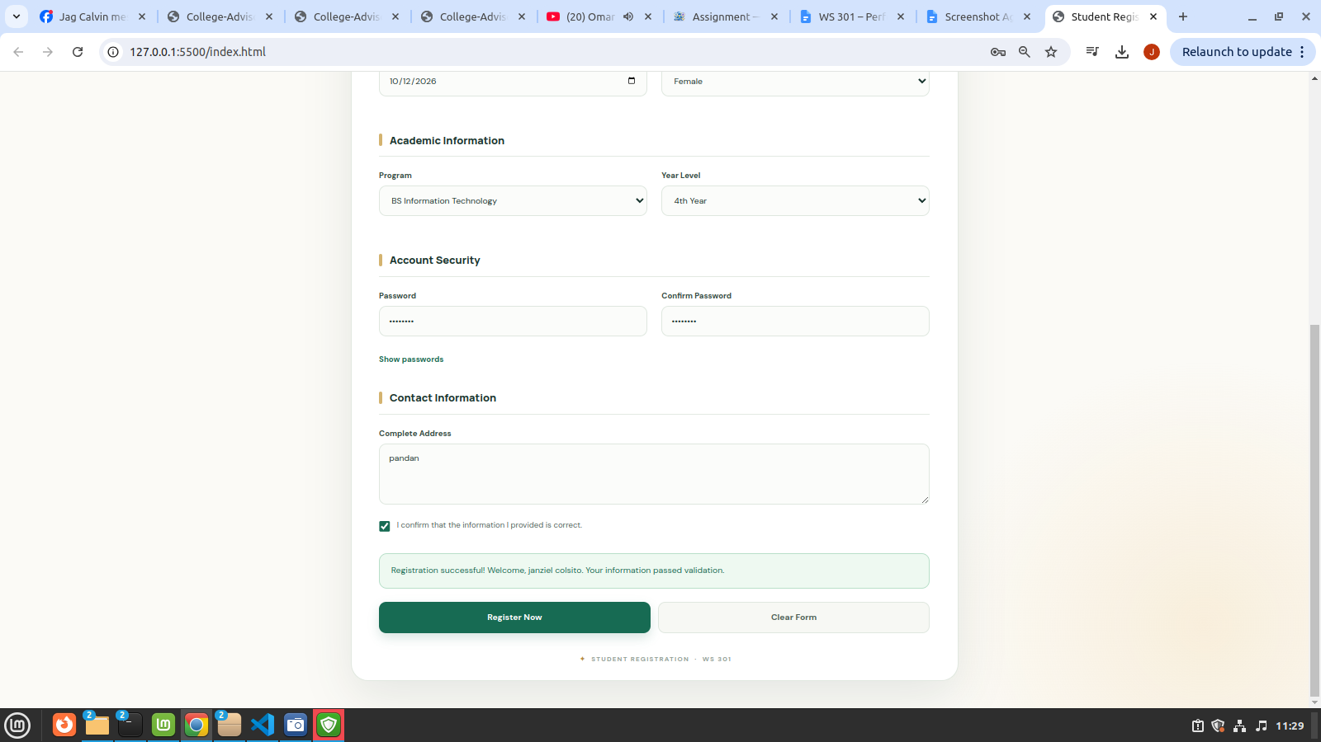
Short Explaination:
My Student Registration Form allows students to enter their personal, academic, and contact information. I validated the required fields, email address, phone number, date of birth, and password confirmation to ensure the information is correct. I used `addEventListener()` to handle form submission and `event.preventDefault()` to prevent the page from refreshing during validation. I displayed specific error messages below invalid fields to help users correct their information. I used `classList.add()` and `classList.remove()` to highlight invalid fields and remove error styling when corrected. I used `classList.toggle()` to create a show-and-hide password feature. I added `data-label` and `data-format` attributes and accessed their values using `dataset` in JavaScript. I also manipulated the `type` attribute to show or hide passwords and the `max` attribute to prevent users from selecting a future date of birth. Finally, the form displays a success message when all information is valid, and the reset button clears the entered information and messages.

